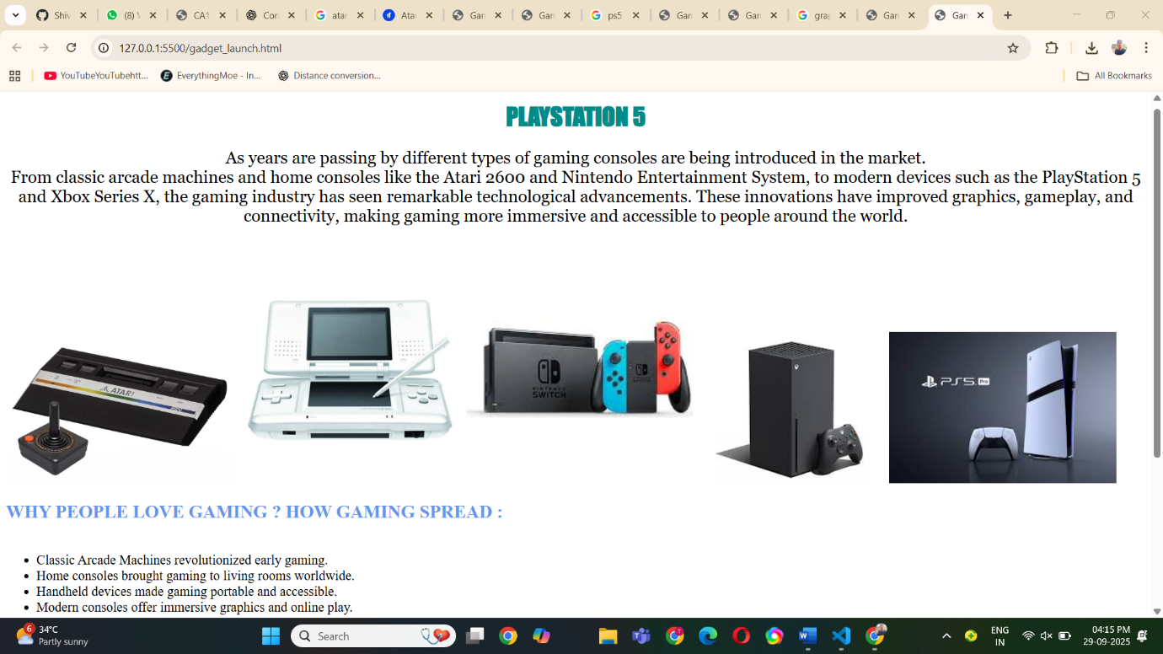

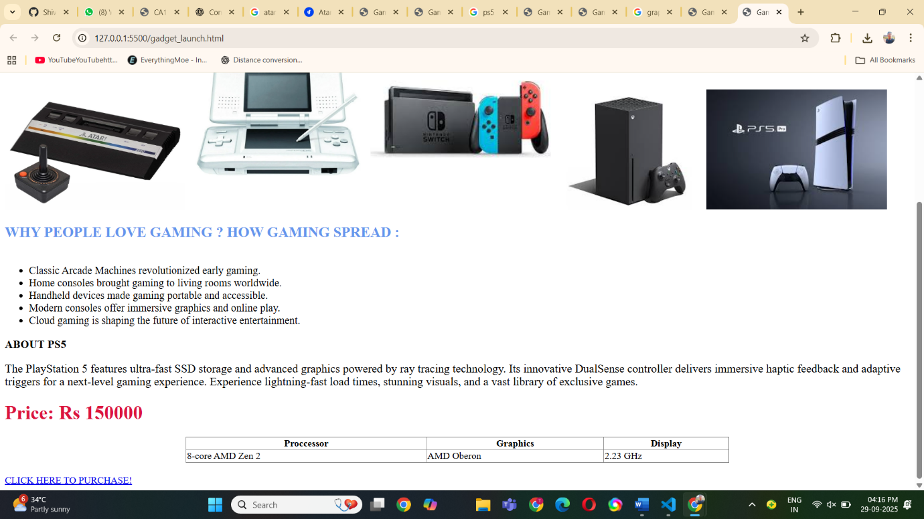

<!DOCTYPE html>

<html lang="en">

<head>

    <meta charset="UTF-8">

    <meta name="viewport" content="width=device-width, initial-scale=1.0">

    <title>Gaming Consoles</title>

</head>

<body>

  <h1 style="text-align: center;color: darkcyan;font-family: Impact, Haettenschweiler, 'Arial Narrow Bold', sans-serif;"> PLAYSTATION 5 </h1>

  <p style="font-size: 1.4em; text-align: center;font-family: Georgia, 'Times New Roman', Times, serif;">

As years are passing by different types of gaming consoles are being introduced in the market.

<br>

From classic arcade machines and home consoles like the Atari 2600 and Nintendo Entertainment System, to modern devices such as the PlayStation 5 and Xbox Series X, the gaming industry has seen remarkable technological advancements. These innovations have improved graphics, gameplay, and connectivity, making gaming more immersive and accessible to people around the world.

</p>

<br>

<!-- Images related to consoles-->

<img src="https://m.media-amazon.com/images/I/51+vUWgGtQL.jpg" alt="Atari" width="300">

<img src="https://i5.walmartimages.com/seo/Pre-Owned-Nintendo-DS-Original-White-Console-Refurbished-Good_969d6751-bc57-44ce-aea9-0f4b6f4060e1.522749e97d4772f0972e6a558d7193b3.jpeg" alt="DS" width="300">

<img src="https://encrypted-tbn0.gstatic.com/images?q=tbn:ANd9GcTevFterDL6uHnkOMKG5Mh2trQ7SJ3V3ZTBnbl3PLG67ImY5ZdjtJIwCeYpnunlh3_MFjE&usqp=CAU" alt="switch" width="300">

<img src="https://encrypted-tbn0.gstatic.com/images?q=tbn:ANd9GcRYFRrbQ9WDJ6hiIreMaoOfVVLfR6gzKlr5bw&s" alt="xbox" width="250">

<img src="https://encrypted-tbn0.gstatic.com/images?q=tbn:ANd9GcRWAhd0yP2kcWGvCRRku49PA6_CLiiJyxhhiA&s" alt="ps5" width="300">

<h2 style="color: cornflowerblue;">WHY PEOPLE LOVE GAMING ? HOW GAMING SPREAD :</h2>

</body>

<!-- About consoles -->

<ul style="font-size: 1.1em; margin-top: 40px;">

  <li>Classic Arcade Machines revolutionized early gaming.</li>

  <li>Home consoles brought gaming to living rooms worldwide.</li>

  <li>Handheld devices made gaming portable and accessible.</li>

  <li>Modern consoles offer immersive graphics and online play.</li>

  <li>Cloud gaming is shaping the future of interactive entertainment.</li>

</ul>

<h3>ABOUT PS5</h3>

<p style="font-size: larger;">

The PlayStation 5 features ultra-fast SSD storage and advanced graphics powered by ray tracing technology. Its innovative DualSense controller delivers immersive haptic feedback and adaptive triggers for a next-level gaming experience.

Experience lightning-fast load times, stunning visuals, and a vast library of exclusive games.

</p>

<h1 style="color: crimson;">

Price: Rs 150000

</h1>

<table border="1" style="width: 60%; margin: 20px auto; border-collapse: collapse;">

<tr>

<th>Proccessor</th>

<th>Graphics</th>

<th>Display</th>

</tr>

<tr>

<td>8-core AMD Zen 2</td>

<td> AMD Oberon</td>

<td> 2.23 GHz</td>

</tr>

</table>

<a href="https://www.flipkart.com/sony-playstation5-console-slim-cfi-2008a01x-1024-gb/p/itm89489e2adcd2c?pid=GMCGZCYPAFYBUNAR&lid=LSTGMCGZCYPAFYBUNARLIR5LG&marketplace=FLIPKART&store=4rr%2Fx1m%2Fogz&spotlightTagId=default_FkPickId_4rr%2Fx1m%2Fogz&srno=b_1_1&otracker=browse&fm=organic&iid=1cec6488-77b0-4c71-b8e9-f0de9873ef25.GMCGZCYPAFYBUNAR.SEARCH&ppt=browse&ppn=browse&ssid=shkxck6k000000001759142602826">CLICK HERE TO PURCHASE!</a>

</html>

<https://github.com/Shivansh1704/ShivanshChaudhary_202501100300237_CSEAI_D.git>